Stereotactic Laser Ablation
AI-Assisted Surgical Probe Path Planning
Results Report — Two Test Cases
This report presents the output of the AI pipeline across two separate T1-weighted MRI test cases. For each case, the pipeline performs three stages: (1) tumor detection using MedGemma, (2) tumor segmentation using a fine-tuned U-Net model, and (3) safe laser probe path planning using a cubic Bézier curve that avoids Broca's region.

Colour Legend (applies to all figures)
🔴 Red contour — Segmented tumor boundary
🟠 Orange curve — Laser probe trajectory (Bézier path)
🟡 Cyan/Yellow circle — Skull entry point for the probe
🟣 Purple region — Broca's area (avoided by probe path)
⬜ White mask — Binary tumor segmentation output

Test Case 1 — Posterior Fossa Tumor

Figure 1.1 — Original T1-Weighted MRI Scan
The raw T1-weighted MRI uploaded for Case 1. This axial slice shows a large, irregularly shaped mass in the posterior region of the brain with bright contrast enhancement around a darker necrotic core — characteristic of a high-grade brain tumor in the posterior fossa.
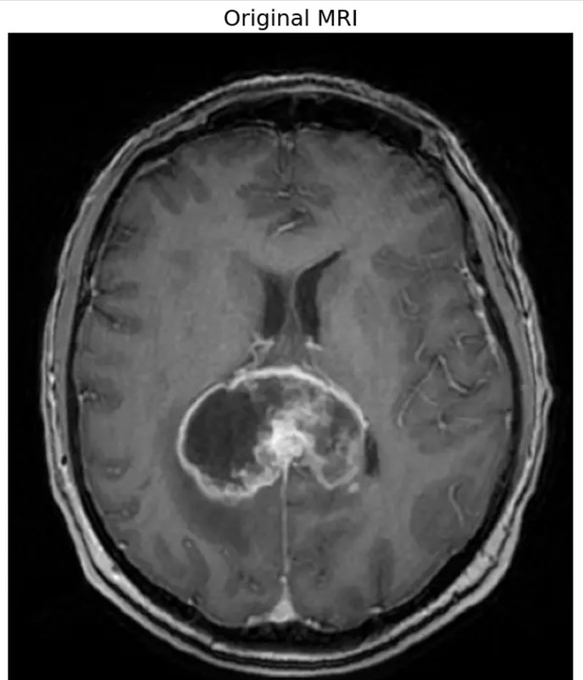
Figure 1.1: Case 1 — Original T1-weighted MRI (unprocessed input)

Figure 1.2 — Tumor Detection & Segmentation
MedGemma confirmed tumor presence. The U-Net model then produced a binary segmentation mask (left), which is overlaid on the scan as a red-filled contour with a semi-transparent highlight (right). The red dot marks the computed tumor centroid — the endpoint for the laser probe.
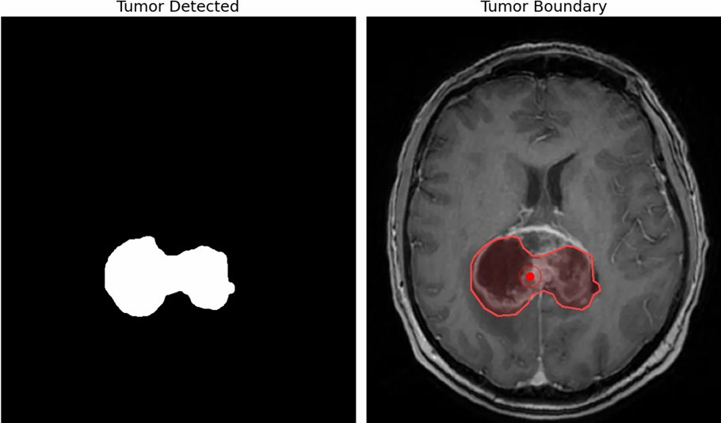
Figure 1.2: Case 1 — (Left) Binary segmentation mask | (Right) Tumor boundary overlaid on MRI

Figure 1.3 — AI Tumor Navigation & Probe Path
The probe path planner generates a cubic Bézier curve from the skull entry point (yellow circle, bottom-left) to the tumor centroid. The purple region marks Broca's area. The orange probe path successfully reaches the tumor center while fully avoiding Broca's region, demonstrating a safe planned trajectory for the laser.
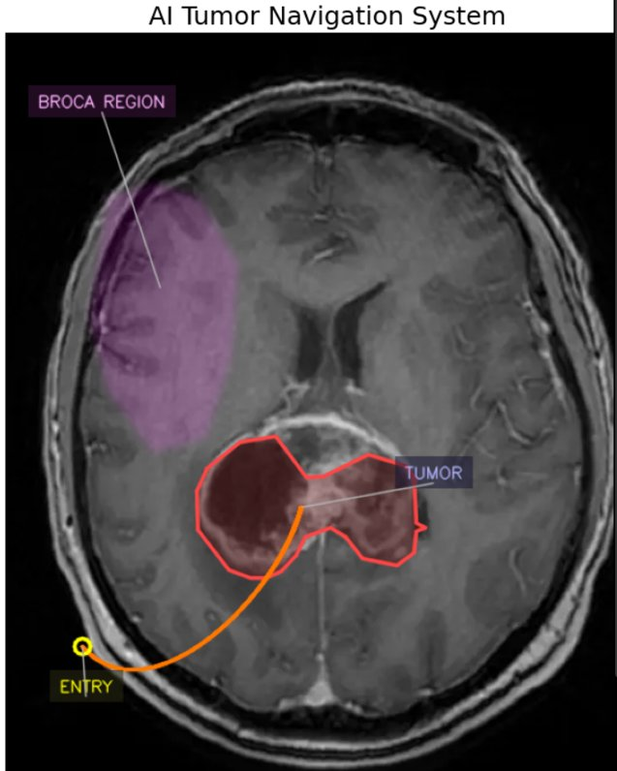
Figure 1.3: Case 1 — Probe trajectory (orange) routed from entry point to tumor center, avoiding Broca's region (purple)

Test Case 2 — Left Hemisphere Tumor

Figure 2.1 — Original T1-Weighted MRI Scan
The raw T1-weighted MRI uploaded for Case 2. This axial slice shows a well-defined, brightly enhancing tumor mass in the left hemisphere of the brain, located close to the lateral ventricles. The tumor presents with a distinct hyperintense (bright white) core surrounded by a slightly irregular margin.
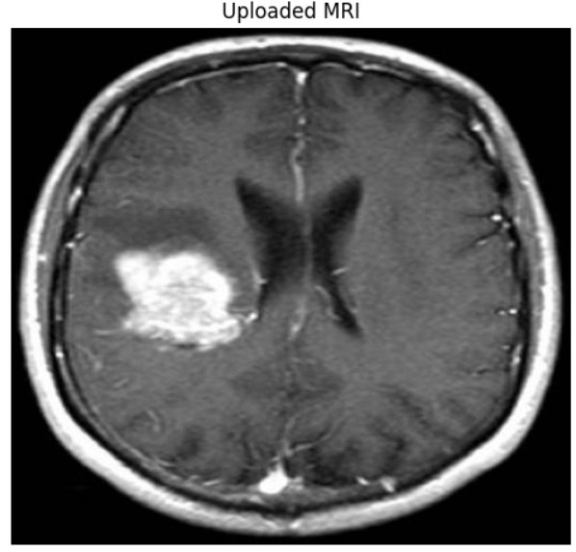
Figure 2.1: Case 2 — Original T1-weighted MRI (unprocessed input)

Figure 2.2 — Tumor Detection & Segmentation
MedGemma confirmed tumor presence. The U-Net segmentation model produced a clean binary mask of the tumor (left). The mask is overlaid on the scan as a red-outlined, semi-transparent contour (right), accurately capturing the shape and extent of the left-hemisphere tumor.
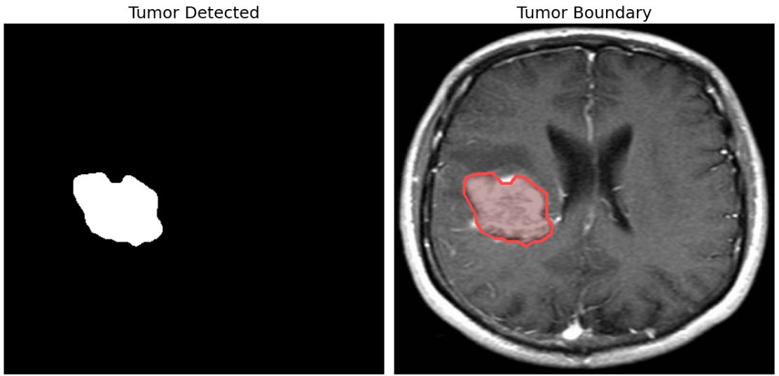
Figure 2.2: Case 2 — (Left) Binary segmentation mask | (Right) Tumor boundary overlaid on MRI

Figure 2.3 — AI Tumor Navigation & Probe Path
For Case 2, the proximity of the tumor to Broca's region presents a more challenging path-planning scenario. The planner generates a curved Bézier path that arcs around the edge of Broca's area (purple) before reaching the tumor centroid. The entry point (yellow circle) is positioned at the lower skull boundary, and the orange path successfully avoids the speech-critical region.
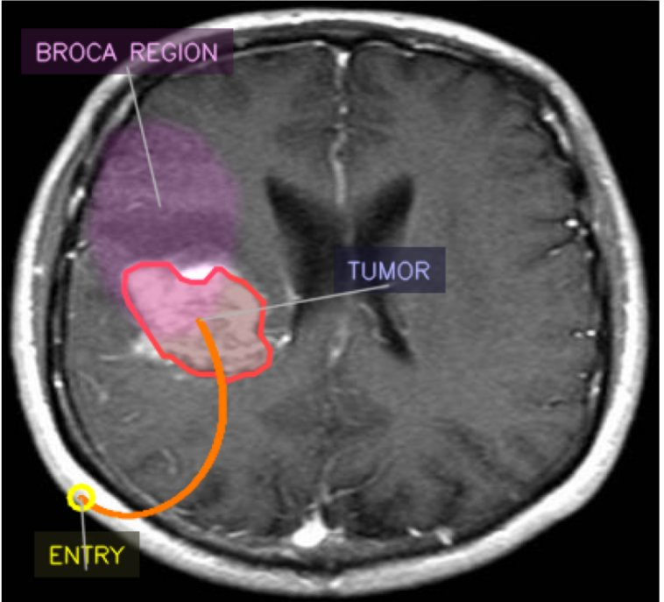
Figure 2.3: Case 2 — Probe trajectory (orange) navigating near Broca's region (purple) to reach tumor center

Summary

Pipeline Performance Across Both Cases
Both test cases demonstrate the end-to-end pipeline functioning correctly. The MedGemma model accurately detected tumors in both scans. The U-Net segmentation model produced clean, well-bounded masks for both cases. The Bézier path planner successfully computed a safe trajectory in both cases — including Case 2, where the tumor's proximity to Broca's region required a more constrained curved path.
⚕️ Disclaimer: This document is generated by a research prototype and is not intended for clinical use. All outputs must be reviewed and validated by a qualified neurosurgeon before any clinical application.

